**Professional Email Writing**

Once the career fair is over, you’ll probably walk out with more business cards than you can count. Whether you get asked to do an interview the next day or not, it is always a good idea to follow up with the companies you were interested in. Doing so will allow you to make connections for future opportunities! Here are some tips and tricks for writing a successful and meaningful professional email:

1. Start with a meaningful subject line

Whether you had a conversation someone or are just sending an email to a person that you hope to make a connection with, make sure to write a meaningful subject line. Remember to keep it short and sweet, but before you write the subject line think about your intentions. The subject line should summarize why you are contacting them. With a stuffed inbox, the subject line can make or break whether the person sends it straight to trash or gives it a read.

1. Address them appropriately

Casual language such as ‘Hey’ may be fine to send to a colleague or friend, but for professional inquiries it is not the best choice. On the other hand, ‘Dear’ is too formal. A simple ‘Hi’ or ‘Hello’ is more appropriate.

1. Keep the email concise and to the point

Although many professionals are excited about inquiring new, talented students into their company, they are also very busy. Especially after a career fair, their inboxes will get crowded with follow-ups. For the best chance that they respond, keep the note short.

1. Make it easy to read

Add indentations or spaces between paragraphs for easy reading and skimming. In addition, keep your most important information to the beginning of each paragraph so they are able to recognize your most important points.

1. Do not use slang

Professional emails require a certain level of formal language. Don’t use slang or emojis. In addition, pick a simple typeface and don’t add too many colors, if any at all.

1. Be kind and thankful

Always remember to be kind and friendly. Remember, they are doing you a big favor. They are typically very busy, and taking time out of their day to talk with students at the career fair or even read and answer an email is nice of them.

1. Be charismatic

Try to stand out. When you write an email, don’t be over dramatic or silly. However, a little wit never hurt anyone. Don’t be afraid to display your personality!

1. Bring up points in your previous conversation

If you had the chance to speak to them at the career fair, try to mention something you talked about that may have been unique. Chances are, the person had a lot of similar conversations with many other kids. Anything you can say that will help them remember you is valuable.

1. Re-read the email

Even when you write quick and short emails, it can easily include mistakes. Small grammatical errors can make or break a professional’s opinion of you. Re-read your email before you send it to avoid any slip-ups.

1. Use an appropriate signature

Two appropriate closers are ‘Best regards’ and ‘Thank you’. Don’t forget to add your name after choosing a closer. Better yet, set an automatic signature so it always appears at the bottom of your emails no matter what.

Follow these simple tips and you’ll be ready to send follow-ups and thank you emails like a pro. Good luck to everyone going to the career fair!

*** writing is an art and doing it well takes know-how and practice. But you don’t have to make all the mistakes for yourself in order to write professional emails.

We assembled for you the essential tips for creating highly effective formal emails with a deep dive into formal email formats, structure, and best practices. We also gathered some real-life examples and templates you can use right away with a few tweaks.

What’s in this article

Basic formal email structure

Formal email writing is usually in a B2B or B2C scenario or a professional email between colleagues, businesses, or partners. Informal email writing is something you might send a friend, family member, or sometimes even a quick email you’re firing off to a colleague.

When you’re emailing a friend there is not much risk in getting your words or meaning wrong, and there is little risk of hurting your reputation or wrecking an incredible business opportunity. But when writing a business email there is much at stake and many things that can go horribly wrong. This is why our article will deal mostly with formal email writing and how to get it right every time.

Here, we’ll go over all the ins and outs of what goes into an email structure, different email formats you can use, as well as short email templates that you can use in various scenarios. Keep reading to learn how to write the perfect email.

**The basic elements of professional email writing:**

Your email address

Subject line

Email opening

Email body

Email ending

Email Sign off

Email signature/footer

Now let’s break these down, one by one.

Email address

Your email address is oftentimes out of your control. If you’re working for a company or operate under the umbrella of a brand your email address will likely include the company or brand name domain.

For example, the emails in WiseStamp are all in the following format: [employee_name]@wisestamp.com. This ensures that we all have a professional business email address. Since only the owner of wisestamp.com can issue email addresses under that domain name, this ensures our emails appear legitimate.

Imagine if each employee would have a random Gmail address like [name][wisestamp@gmail.com](mailto:wisestamp@gmail.com), which anyone can create, that would be a bit suspicious. Email open rates are first and foremost dependant on trust, so make sure you have a trustworthy email address or suffer very low open rates.

Subject lines

Your subject line will be the single most important element in your formal email writing. It is the first thing your recipient will see and unless you convince her then and there that your email is safe, relevant, and high priority (in that order) it may never be opened. If this happens, any effort you put into the rest of the email elements will go to waste.

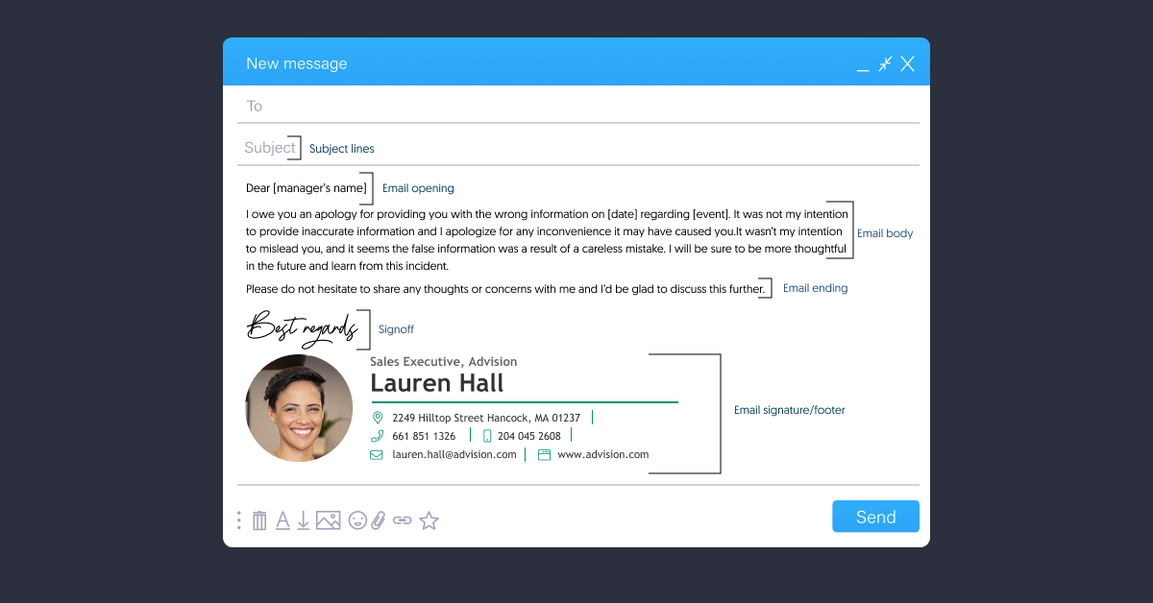

Your subject line will depend on the purpose or content of your email, but overall, you want it to be something engaging enough for a recipient to click on.

Email subject line guidelines:

Be clear and specific – avoid using generic or clickbait subject lines that say nothing or make unrealistic promises, like “find out how to double your business in a week”.

Be original – avoid using those all too common subject line templates you find on the internet. Instead make original subject lines that are relevant, personal, and concise.

Add relevancy – address something that the recipient will recognize, like an acquaintance name or a an article/ show/ book they appeared on.

Email opening

The next most important way to hook a recipient into your email is by writing a strong email opening line. Like your subject line, the email opening is mostly used as another filtering stage for most people. If it fails to meet the promise made in the subject line, your readers will ditch.

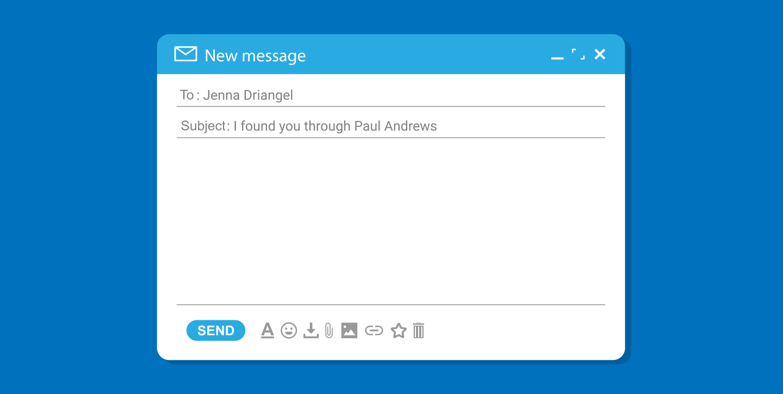

Therefore, it’s extremely important to define your main point in 1 or 2 paragraphs tops. If you clearly convey your request or question and your reader feels it’s relevant and interesting, then they’ll continue reading your email. If you manage to get them to stay after this point, in most cases, they’ll return your email. Good for you.

Email opening guidelines:

Address your recipient by their prefered name – look up an article they’ve written or their linkedin page and see what name they use. Some people will use their full name or their nickname accordingly (for example David vs Dave, or Anastasia vs Ana).

Establish a connection – connect your email to a personal experience that involves the recipient, like an article or a news piece you’ve read about them, or a conversation you had with an acquaintance.

Match the opening with the subject line – your opening message has to mirror the promise made in the subject line because this is how the reader validates relevancy. If you don’t connect subject line to opening, readers will be confused and even assume clickbait.

Get to the point fast – tell your reader why you contacted her and what’s in it for her.

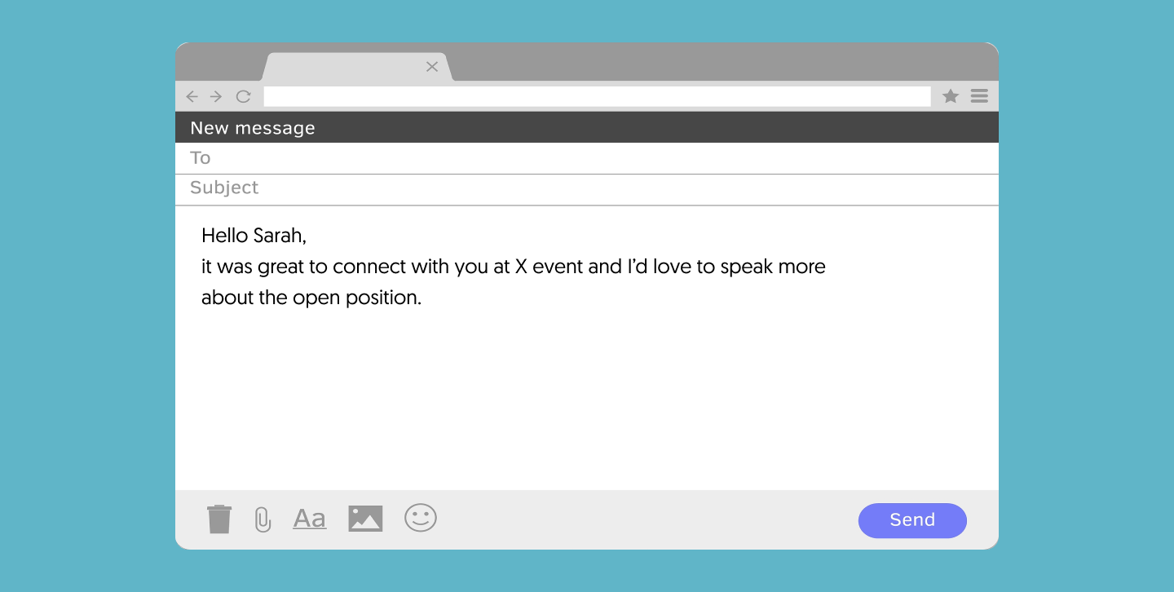

### Email body

The body of your email is where you get into your main message. Whether you’re composing an email to establish a new business connecting or just following up on a meeting, the body of your email should be detailed enough that the reader isn’t confused, but also brief and to-the-point. No one wants to sit and read a long-winded email when they have dozens of other unattended messages in their inbox.

**Email body writing guidelines:**

* **Be concise** – detail only what’s needed to get your point across.
* **Use words that convey (authentic) positive personal emotional** – words like “glad”, “excited”, “intrigued”, “confident”.
* **Use the word “because**” when asking for something – it’s been scientifically shown that people are more easily convinced to do something if told why, and more so if the reason is important for them.
* **Show don’t tell** – if you can’t explain something in few words, see if you can add a screenshot, a video or a link that explain it better.
* **Use headings to split long content into sub-topics** – if you can’t avoid writing a long email, make sure to break it up into subsections with headings. This will help your time-scarce readers to scan and find their points of interest.
* **Add your concrete request or question in bold text** – to ensure your readers do not miss the most important piece of content (your request or question) – set it in a separate line and put it in bold. You can also use some color. If you do avoid light shades (you want high contrast between the text and the white background. Once you pick a color – stick with it.

Email ending

After you’ve addressed all your main points in the body of your email, you’ll want to end it with a respectful and brief salutation. You can either invite your recipient to reach out for more questions, wish them success, or ask a question. It all depends on the motive for your email. If it was a long email it could also be a good idea to gently reiterate your main request, question, or motivation.

Email sign-off

When closing your email, you’ll want to choose a suitable email sign-off. There are different sign-offs you can use for each occasion, such as “best regards,” “sincerely,” or “with love,” but you obviously wouldn’t want to send the last one to your manager. Make sure your signoff is appropriate to your email content and your recipient.

Email signature/footer

Your email signature (or footer) is your wave of goodbye. The way you do this can affect the impression you’ve made up to this point. If you make this moment memorable, organized, and aesthetic you can get some extra credit and a positive attitude from your reader. On the other hand, if you mess this up, your entire message or offer may be put in doubt. So, make sure your email signature looks visually appealing and well organized.

